Contents

Chapter 01 5

1.1 PACT Analysis 5

1.1.1 People 5

1.1.2 Activity 5

1.1.3 Context 6

1.1.4 Technology 6

Chapter 2 6

2.1 System Interface 6

2.1.1 Home page 6

2.1.2 Navigation bar 6

2.1.3 Login 7

2.1.4 User Dashboard 8

2.1.5 Change password 9

2.1.6 Exam Registration 9

2.1.7 Course Registration 10

2.1.8 View Result 11

2.1.9 Attendance 12

2.1.10 Food Order 12

2.1.11 Notices 13

2.1.12 Logout conformation 14

Chapter 3 15

3.1 Keystroke level modeling 15

Figure 1: Index page 6

Figure 2: Existing navigation bar 6

Figure 3:Proposed navigation bar 7

Figure 4:Existing system login 7

Figure 5:Proposed system login 7

Figure 6: Existing dashboard 8

Figure 7: Proposed dashboard 8

Figure 8: Existing system change password 9

Figure 9: Existing system Exam Registration 9

Figure 10: Proposed system exam registration 10

Figure 11: Existing System course registration 10

Figure 12:Proposed course registration 11

Figure 13: Proposed system view results 11

Figure 14:Existing system attendance 12

Figure 15: Existing system food order 12

Figure 16:Proposed system food order 1 12

Figure 17: Proposed system food order 2 13

Figure 18: Proposed system food order 3 13

Figure 19:Existing system notice 13

Figure 20: Proposed system notice 14

Figure 21: Proposed system old notices 14

Figure 22:Proposed system logout conformation 14

Introduction

TECMIS is the official Information management system website of the Faculty of Technology, University of Ruhuna. This website is used by the Lectures and all students of the faculty. As well as each and every student should keep a continuous interaction with TECMIS because the important notices will be posted, and course and exam registrations will be helpful with using this system. But the current system is not having a user-friendly interface and there are some features that’s having some mistakes. So, those issues should be corrected in an effective manner

In this project, we are going to redesign an interface for the TECMIS following HCI principles. So, it will be an effective and efficient web page. In our design, we focused on the user-friendliness, usability, and completeness of the functions

# Chapter 01

## PACT Analysis

### People

|  |  |  |
| --- | --- | --- |
| User | Characteristics | Goals |
| Student | * Can be male or female * Above 19 years old * Purpose visit to the system * May or may not have experience | * User-friendly interaction * Good impression * Easy access to functions * Provide a guide for first time user * Simple format and design * Information sharing * Giving feedback feature |
| Lecture | * Can be male or female * Purpose visit to the system * May or may not have experience with this type of system | * Quick access to the function * User-friendly interface * Easily find functions * Provide a user guide for the first use * Feedback feature |
| Dean |  |  |
| Administrator | * Can be male or female * Expert knowledge * May have experience |  |

### Activity

|  |  |
| --- | --- |
| User | Activity |
| Student | * View notices * View course registration * Register for the courses * Register for the exams * View exam results * View GPA * View mentor details * Order foods * Change the personal details * Change password |
| Lecture | * Post, View notices * View mentoring details * Change personal details * Change password * View the course list |
| Dean | * Post, View notice * View student details * View lecture details * Change password |
| Administrator | * Manage notices * Manage Students * Manage lectures * Manage Exam registrations * Manage course registrations |

### Context

* Can access the system from any location
* Can access the system any time
* Limited people can access the system
* Use the system for some purpose

### Technology

* Smartphones, Laptops
* Touch or mouse-based
* Touch or physical keyboard
* GUI

# Chapter 2

## 2.1 System Interface

### 2.1.1 Home page

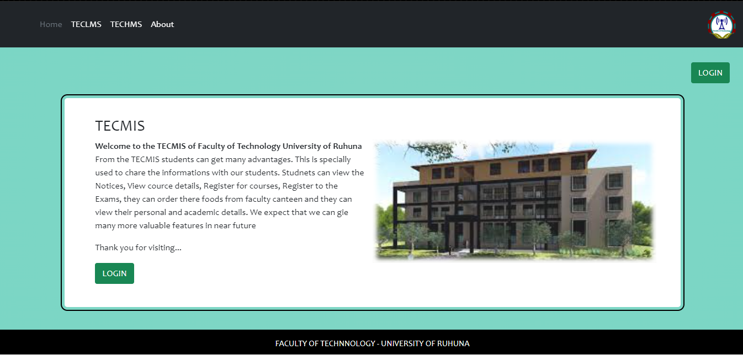

TECMIS

Figure 1: Index page

### 2.1.2 Navigation bar



Figure 2: Existing navigation bar

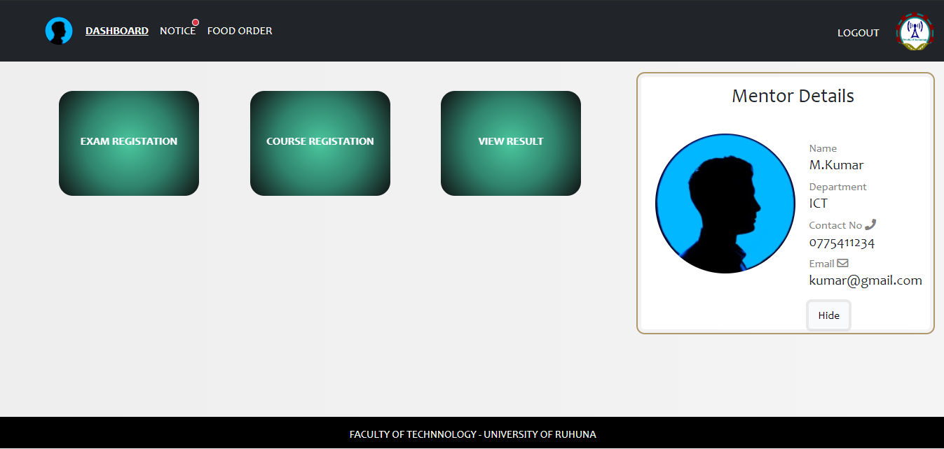

TECMIS

Figure 3:Proposed navigation bar

### 2.1.3 Login

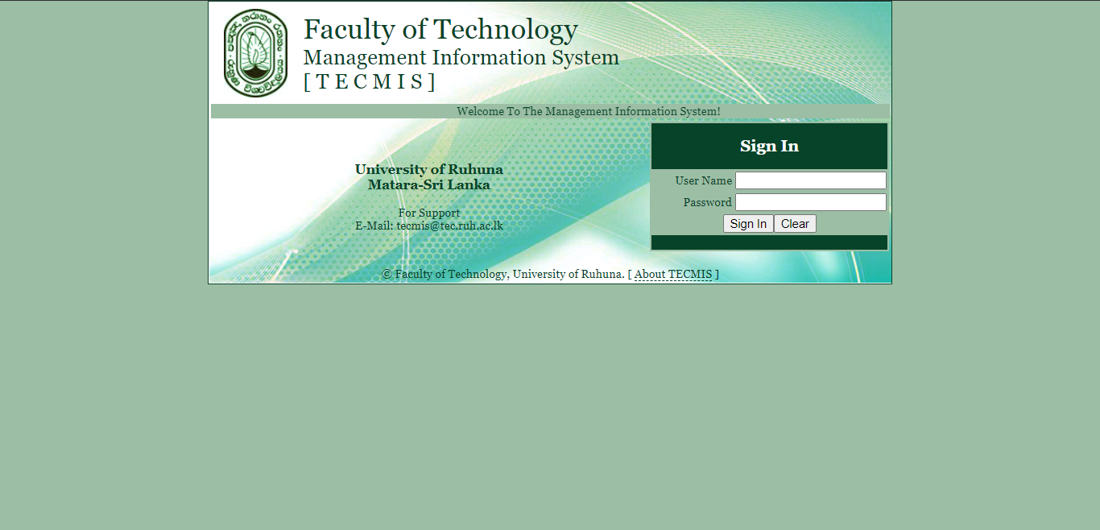

Figure 4:Existing system login

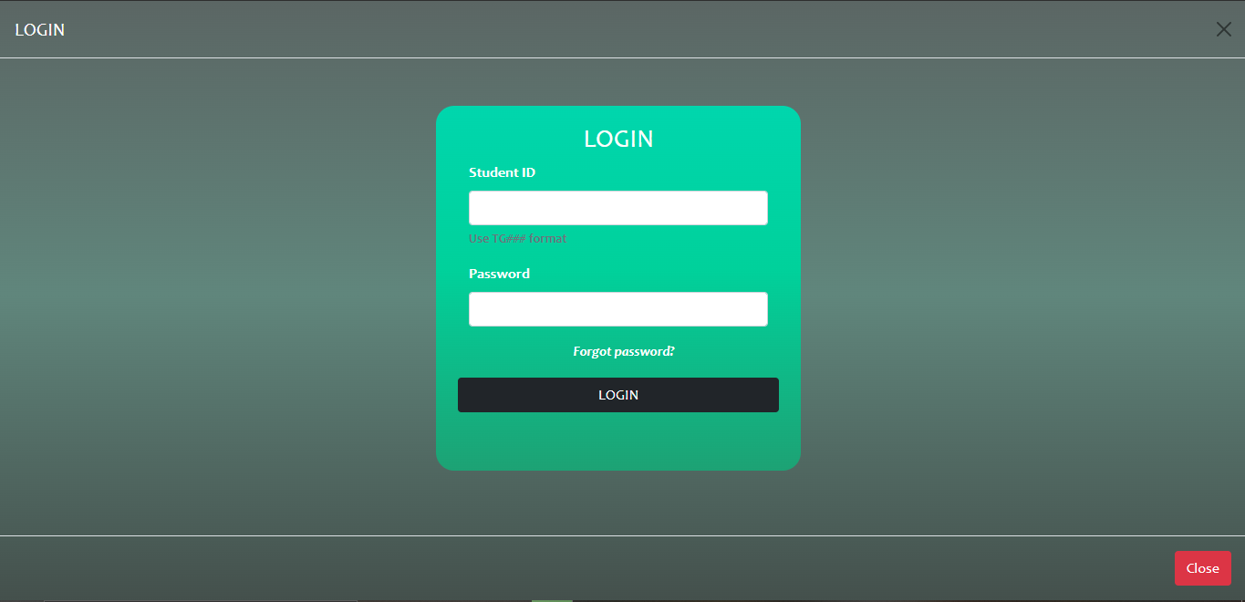

Figure 5:Proposed system login

### 2.1.4 User Dashboard

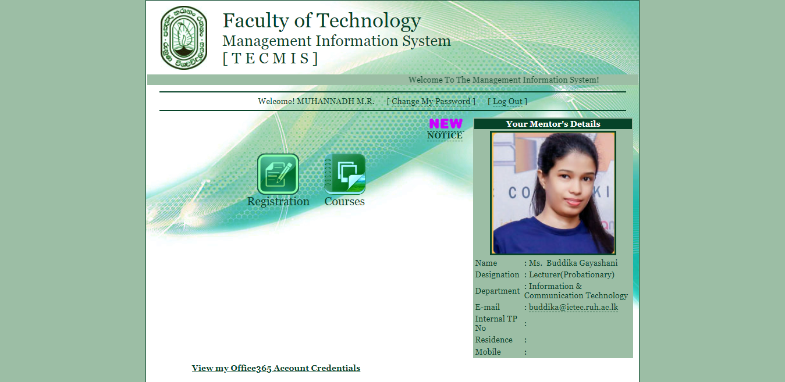

Figure 6: Existing dashboard



TECMIS

Figure 7: Proposed dashboard

### 2.1.5 Change password

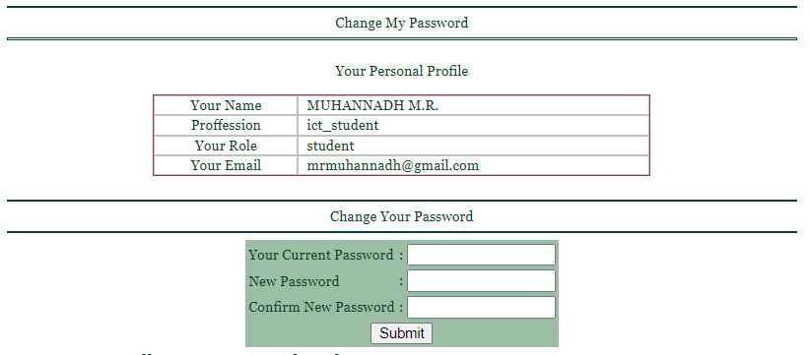

Figure 8: Existing system change password

### 2.1.6 Exam Registration

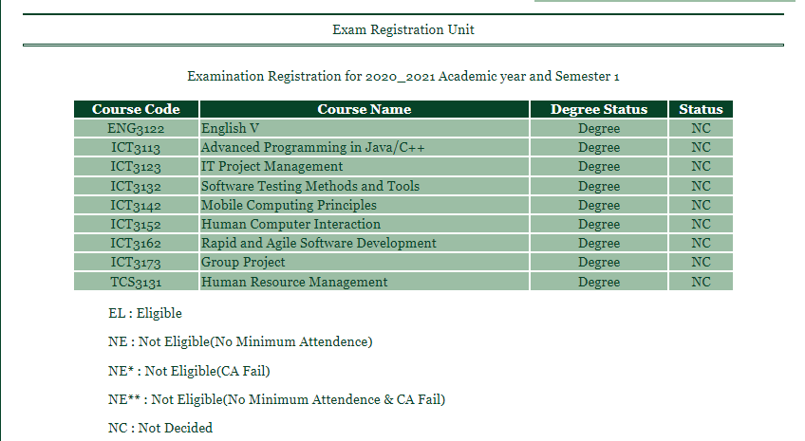

Figure 9: Existing system Exam Registration

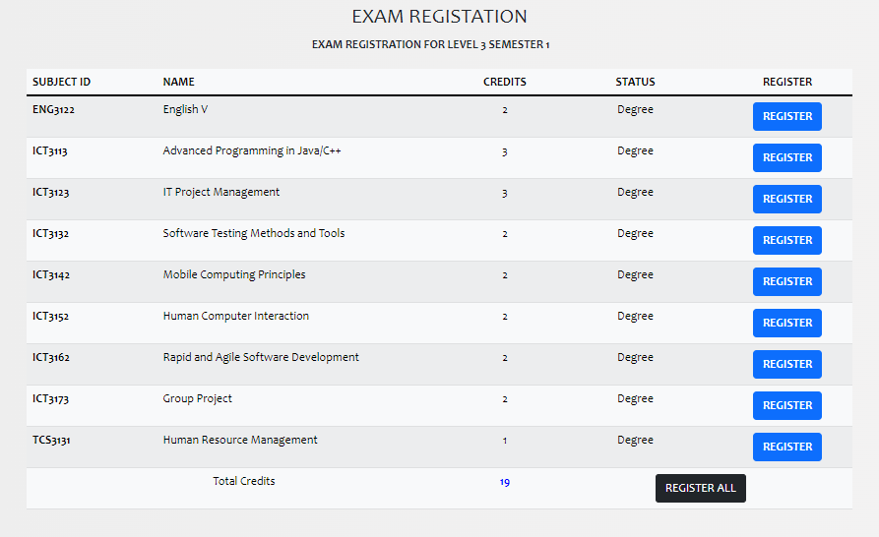

Figure 10: Proposed system exam registration

### 2.1.7 Course Registration

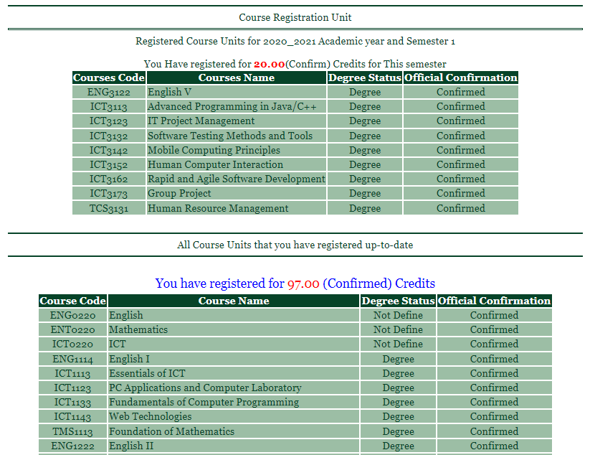

Figure 11: Existing System course registration

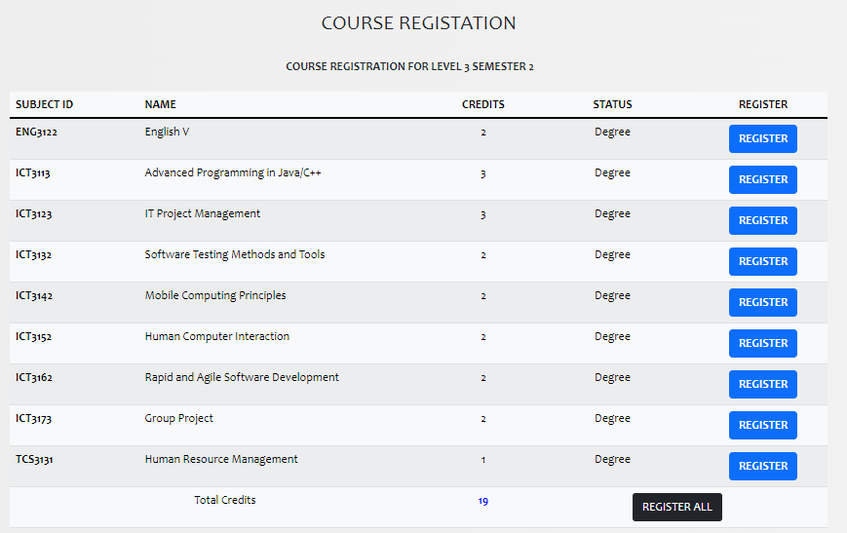

Figure 12:Proposed course registration

### 2.1.8 View Result

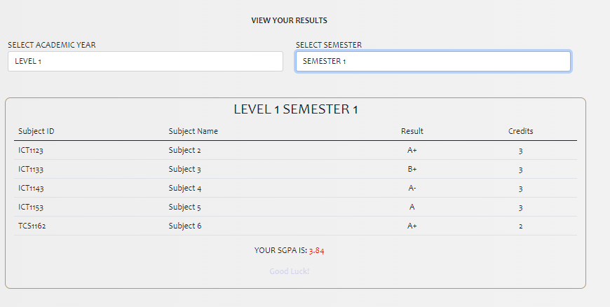

Figure 13: Proposed system view results

### 2.1.9 Attendance

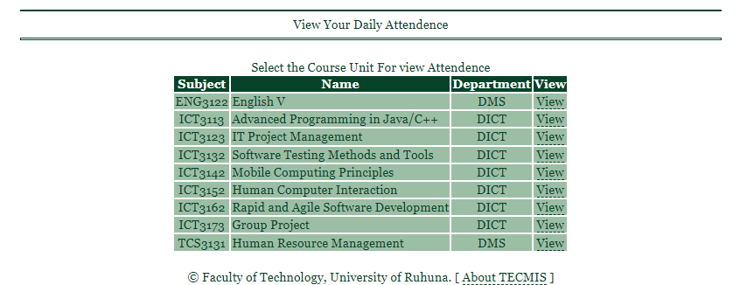

Figure 14:Existing system attendance

### 2.1.10 Food Order

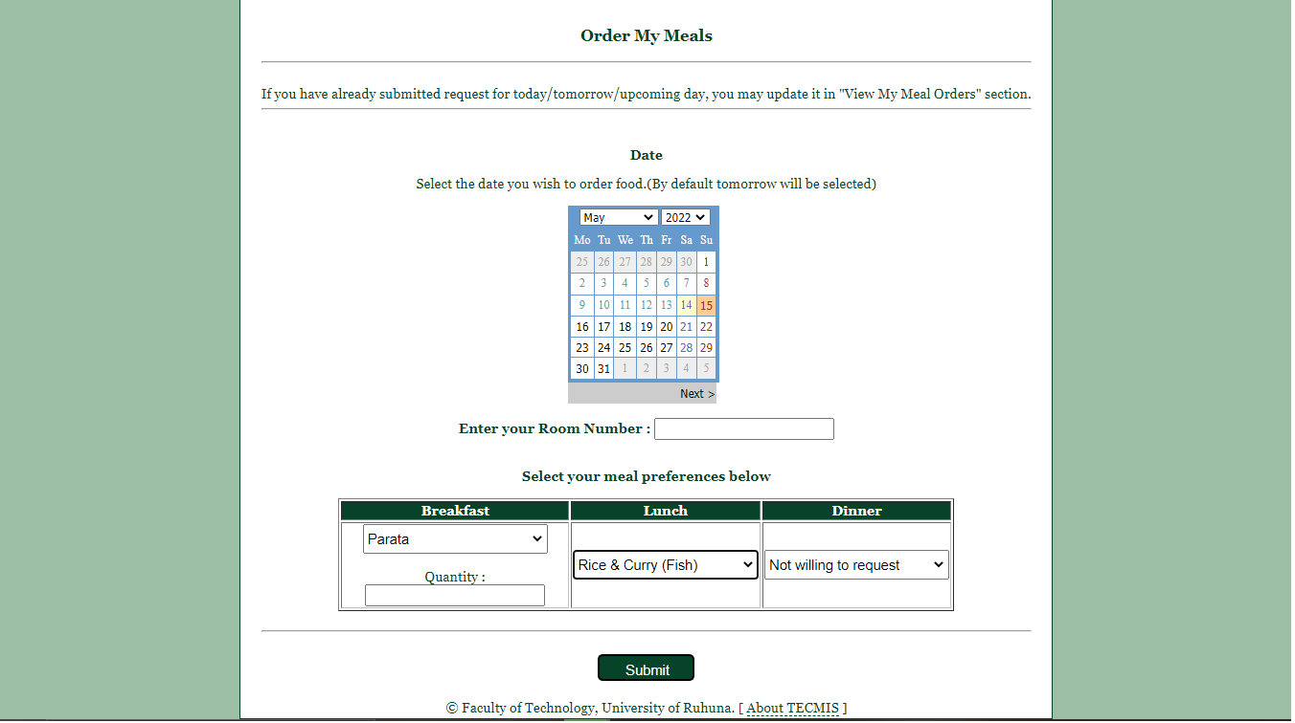

Figure 15: Existing system food order

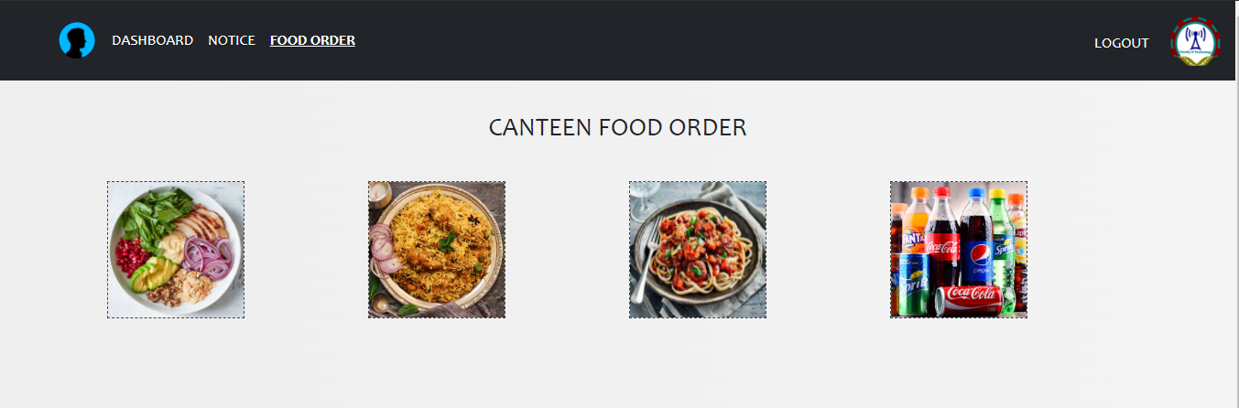

Figure 16:Proposed system food order 1

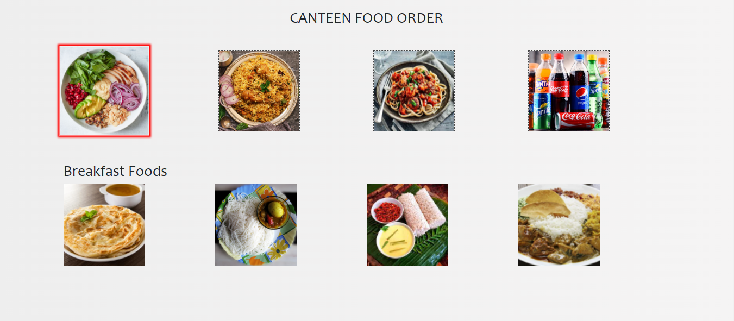

Figure 17: Proposed system food order 2

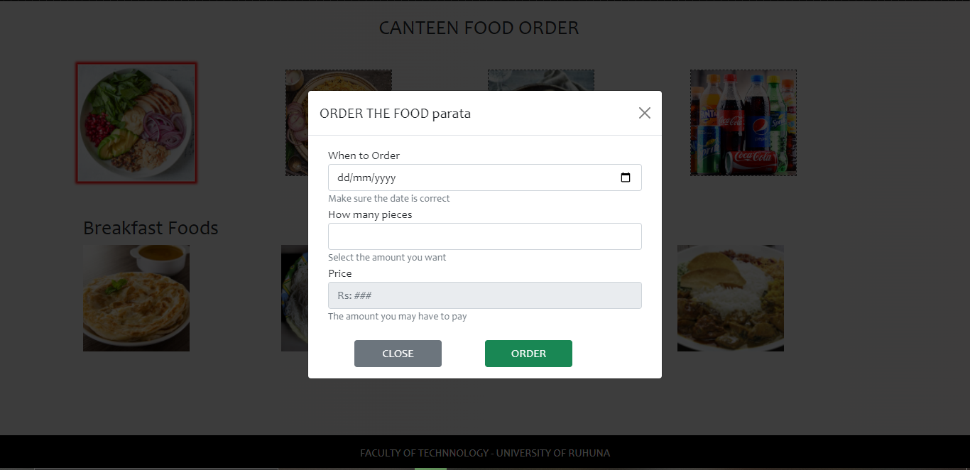

Figure 18: Proposed system food order 3

### 2.1.11 Notices

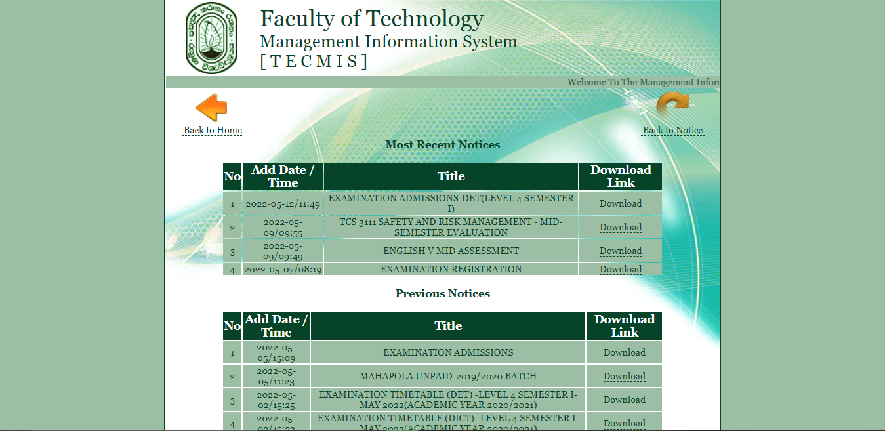

Figure 19:Existing system notice

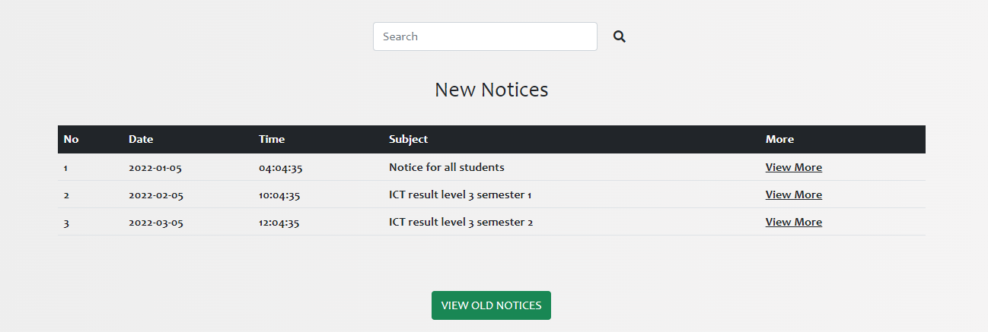

Figure 20: Proposed system notice

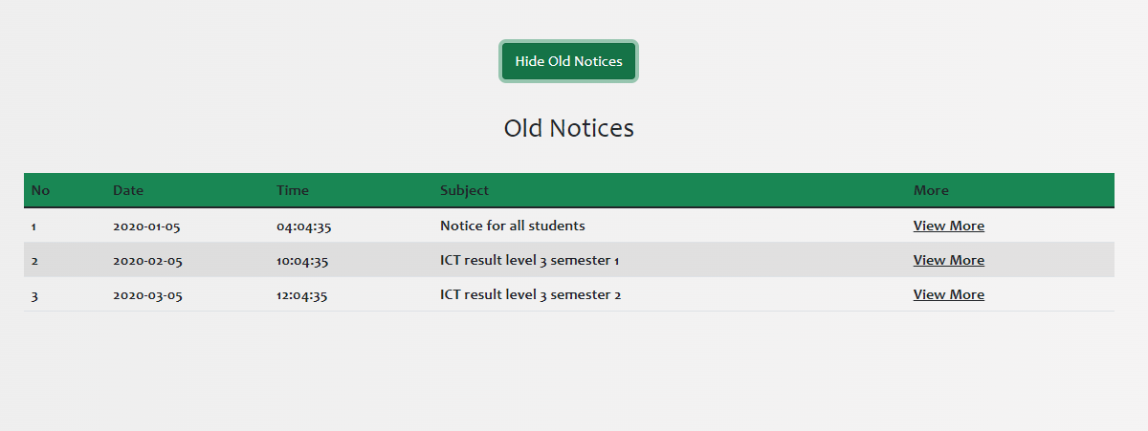

Figure 21: Proposed system old notices

### 2.1.12 Logout conformation

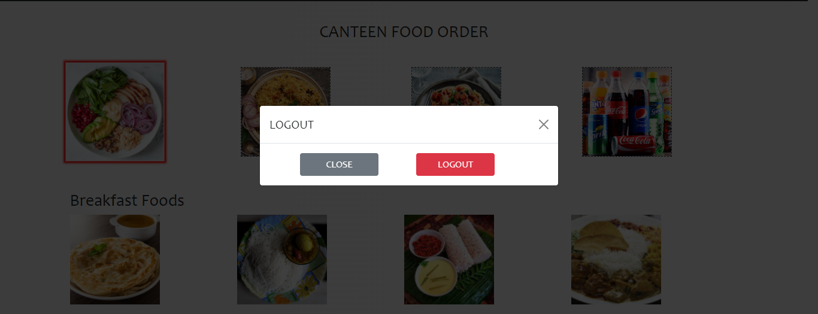

Figure 22:Proposed system logout conformation

# Chapter 3

## 3.1 Keystroke level modeling